1. Download all files in description.
2. Open ende.py in any Python IDE or editor.
   1. I used PyCharm
      1. <https://www.youtube.com/watch?v=56bPIGf4us0>
3. Looking at the code, we can see how the program functions. It is a command line tool used to de/encrypt messages, and requires a password to do both. Reviewing the code, under the “help_msg” variable, instructions are given for how to use the tool.
   1. https://www.geeksforgeeks.org/how-to-use-sys-argv-in-python/
4. Open up the terminal and navigate (use *cd* command) to folder where ende.py is stored.
5. Type in the command *python3 ende.py -d flag.txt.en*
6. Open up “pw.txt” to find a password.
7. Enter the password into terminal.
8. The flag is decrytped.

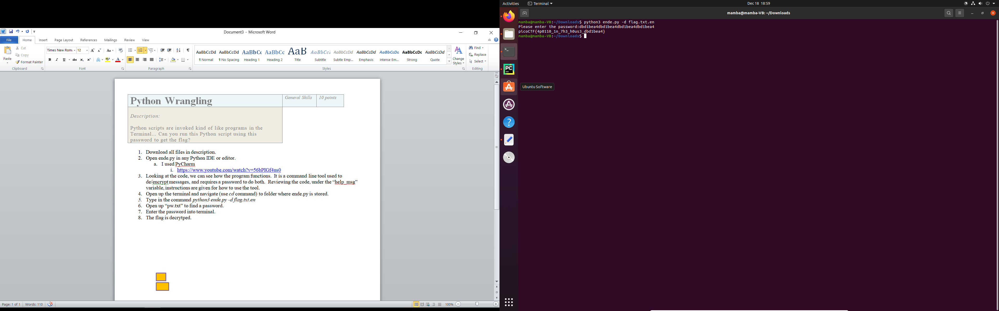

6

5